ELLERSLIE CHIROPRACTIC AND WELLNESS CENTRE
Consultation Admittance Form

Last Name: (Mr. Mrs. Miss) |  | First Name: |  | Today’s Date:
Address: |  | City, Province: |  | Postal Code:
Phone (Home): ( ) |  | Phone (Work): ( ) |  | Phone (Cell): ( )
Alberta Health Care #: |  |  | Gender: M / F |  | Marital Status: (circle)  Single Married Widowed Divorced
Emergency Contact Name: |  |  | Emergency Contact Phone : ( )
Date of Birth: | Age: |  | Height: |  | Weight:
Occupation: |  |  | Who may we thank for referring you?
Email Address (optional)
(Emails will be used strictly for the purpose of appointment reminders ):

***************************************************************************************************************************************
Reason(s) for appointment:
When did your condition begin? Is it getting worse?
Time of day problem occurs most: ________________________________________________________________________________
Have you ever had similar problems? Yes No
Have you had X-rays, MRI, or other tests for this condition? Yes No Which tests, when?
____________________________________________________________________________________________________________
Provide details as to what aggravates your condition:
What makes your condition better? ______________________________________________________________________________
Is this a work related injury? Yes No Has your employer been notified? Yes No
Is this a Motor Vehicle Accident (MVA)? Yes No If yes, please be sure to advice reception
Can you perform daily home activities? Yes Yes, but only with help Not at all
Can you perform your daily work activities? All activities Only some activities Not at all
Describe your stress level None Mild Moderate High
Do you exercise? Daily Occasionally Not at all
List all previous surgeries, illnesses, and injuries:

Have you had previous chiropractic care? Yes No Dr. Date: _______
What were you treated for? __________________________________ Did it help? ________________________________________
Family doctor name: Dr.
List all medications, over the counter and prescriptions, supplements, vitamins, herbal supports, aspirin, etc.:

Date: __ Patient signature: ________
Health History Questionnaire

Patient name Date

Have you ever been diagnosed or told you have any of the following? Circle the correct response.

- High blood pressure Yes No
- Hardening of the arteries (arteriosclerosis) Yes No
- Diabetes Yes No
- Tuberculosis Yes No
- Cancer Yes No
Where?
- Heart or blood diseases Yes No
- Bone spurs on the neck bones (cervical sprain) Yes No
- Whiplash injury (flexion-extension injury, cervical sprain) Yes No
- Have you or any of your relatives ever suffered a stroke? Yes No
- Were you ever a smoker? Yes No
From to
- Do you take medication on a regular basis? Yes No
- Visual disturbances (blurring, loss, double vision) Yes No
- Hearing disturbances (loss, ringing, other noise) Yes No
- Slurred speech or other speech problems Yes No
- Difficulty swallowing Yes No
- Dizziness Yes No
- Loss of consciousness, even momentary blackouts Yes No
- Numbness, loss of sensation, loss of strength or weakness in the face,
fingers, hands, arms, legs, or any other parts of the body? Yes No
- Sudden collapse without loss of consciousness Yes No

Indicate the location of your pain by shading in the appropriate area(s):
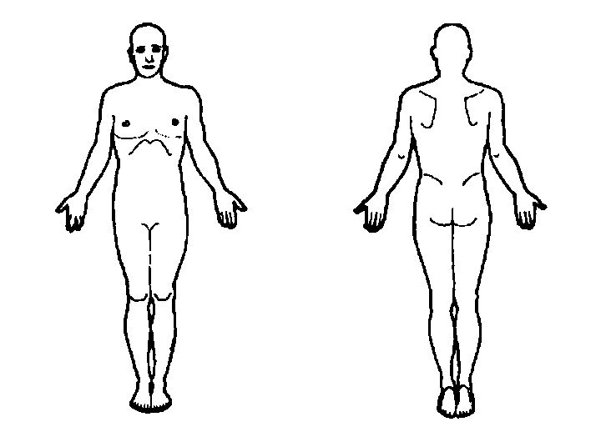
Indicate the severity of the pain by circling a number:

| 0 1 2 3 4 5 6 7 8 9 10 |
No pain Extreme pain

Systems Review Patient Name: Date:

Circle any conditions that are presently causing you a problem.
Underline those that have caused you problems in the past.

GENERAL SYMPTOMS | RESPIRATORY | GENITOURINARY
Fever  Sweats  Fainting  Sleep disturbance  Fatigue  Nervousness  Weight loss  Weight gain | Chronic cough  Spitting up phlegm  Spitting up blood  Chest pain  Wheezing  Difficulty breathing  Asthma | Frequent urination  Painful urination  Blood in urine  Pus in urine  Kidney infection  Prostate trouble  Uncontrollable urine flow
NEUROLOGICAL | CARDIOVASCULAR | GASTROINTESTINAL
Visual disturbance  Dizziness  Fainting  Convulsions  Headache  Numbness  Neuralgia (nerve pain)  Poor coordination  Weakness | Rapid beating heart  Slow beating heart  High blood pressure  Low blood pressure  Pain over heart  Hardening of arteries  Swollen ankles  Poor circulation  Palpitations  Cold hand or feet  Varicose veins | Poor appetite  Difficult digestion  Heartburn  Ulcers  Nausea  Vomiting  Constipation  Diarrhea  Blood in stool  Gallbladder/jaundice  Colitis
EYES, EARS, NOSE, THROAT | MUSCLE & JOINT | FOR WOMEN ONLY
Eye pain  Double vision  Ringing in ears  Deafness  Nosebleeds  Trouble swallowing  Hoarseness  Sinus infection  Nasal drainage  Enlarged glands | Neck pain  Low back pain  Arm pain  Shoulder pain  Leg pain  Knee pain  Foot pain  Pain/numbness down arms or legs  Pain between shoulders swollen joints  Spinal curvature  Arthritis  Fractures | Painful menstruation  Hot flashes  Irregular cycle  Cramps or back pain  Vaginal discharge  Nipple discharge  Lumps in breast  Menopausal symptoms  Birth control pills  Miscarriages  Complications with pregnancy  Pregnant? Y / N Week?  Other:

